Southeast Pain and Spine Care – Healow, Online Patient Portal
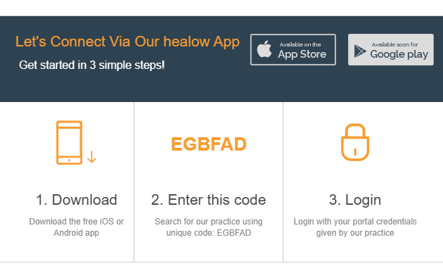

Email: SoutheastPainConsultantsBilling@napaanesthesia.com if you would like to be setup on the patient portal.

